## 

**Project Report**

**STYLE STEP**

**(ONLINE SHOE MENEGEMENT SYSTEM)**



**Submitted By:**

**MUHAMMAD ZAHID F2021065216**

**University of Management and Technology**

**C-II Johar Town Lahore Pakistan**

Table of Contents

1. Introduction 4

1.1 Purpose: 4

**1.1.1** Product: 4

**1.1.2** Types of Readers: 4

**1.1.3** Purpose: 4

1.2 Document Conventions: 4

1.3 Project Scope: 5

**1.3.1** Description: 5

**1.3.2** Business Objectives: 5

2. Overall Description: 6

2.1 Product perspective: 6

**2.1.1** Context and Origin: 6

**2.1.2** Data Flow Diagram: 7

2.2 User classes and characteristics 7

**2.2.1** User Classes: 7

2.3 Operating environment 8

**2.3.1** Hardware Platform: 8

**2.3.2** Operating system(OS) Versions: 8

**2.3.3** Geographical Locations of Users: 8

**2.3.4** Servers and Databases and Their Hosts: 8

**2.3.5** Host Websites: 8

2.4 Design And Implementation constraints 8

3. System Features 10

3.1 System Feature 1 10

3.2 System Feature 2 11

3.3 System Feature 3 11

3.4 System Feature 4 12

3.5 System Feature 5 12

4. Data requirements 14

4.1 Logical data model 14

5. External interface requirements 16

5.1 User interfaces 16

6. Quality attributes 20

**List of Figures**

Figure 1: Context Diagram 6

Figure 2: Data Flow Diagram 7

Figure 3: Use case Diagram 10

Figure 4: ERD Diagram 14

Figure 5: User Interface Home 16

Figure 6: User Interface View Shoes 17

Figure 7: User Interface Payment 18

Figure 8: User Interface Order confirmation 19

## 

# Introduction

## Purpose:

### Product:

Online Shoe Management System

### Types of Readers:

* Customers
* User
* Customer Support
* Requirement Development Team
* Staff
* Administrator
* Designing Team
* Development Team
* Maintenance Team
* Testing Team

### Purpose:

The purpose for this Shoe Management System is to ensure that the platform meets the needs of different users and provides a seamless online shopping experience for customers. The requirements also help in creating a reliable and user-friendly platform for customers to explore, purchase, and manage their shoe orders.

## Document Conventions:

|  |  |
| --- | --- |
| **Acronym** | **Definition** |
| Streamline | Enhance efficiency |
| OS | Operating system |
| iOS | IPhone operating system |
| Conversion Rates | Refers to the percentage of website or app visitors who complete a desired action, such as making a purchase or filling out a form. |
| Host Websites | Describes the dedicated websites or domains where the Shoe Management System is hosted and accessed by users through web browsers |
| CRM platforms | Customer management software for maintaining customer relationships |
| APIs | Interfaces enabling communication between software applications |
| Data exchange protocols | Rules for transferring data between systems |
| ERD | Entity-Relationship Diagram |
| DFD | Data flow diagram |

## Project Scope:

### Description:

The Shoe Management System is a powerful software solution that offers a comprehensive range of features for efficient shoe management. With the ability to browse through available shoe products, customers can easily find their desired items and add them to their shopping cart. They can manage their account details, update personal information, and make purchases through a seamless checkout process. Tracking orders provides real-time updates on shipment progress and estimated delivery dates. Store managers can manage inventory by adding new products, updating details, and removing discontinued items. User management allows the administration of user accounts, including account creation, modification, deactivation, and issue resolution. The system also provides valuable analytics for sales, inventory, and user activity. Additionally, order management capabilities enable effective oversight of the order fulfillment process. Overall, the Shoe Management System simplifies the browsing, purchasing, tracking, and management of shoes, enhancing the customer experience and optimizing business operations.

### Business Objectives:

* **Enhance Customer Experience:** Customers can manage their accounts, update personal information, and make purchases with ease, ensuring convenience and satisfaction.
* **Drive Sales and Conversion:** This provide a smooth and secure transaction process, the system aims to boost sales and conversion rates.
* **Improve Order Tracking and Transparency:** This feature aims to build trust and loyalty among customers.
* **Streamline Inventory Management:** The system empowers users to manage the inventory of shoes by adding new products, updating existing product details, and removing discontinued or out-of-stock items.
* **Enhance User Account Management:** This feature facilitates effective user administration, personalized customer experiences, and efficient customer service.
* **Data-Driven Decision Making:** The system provides users with analytics functionality, allowing them to view sales, inventory, user activity, and other relevant metrics.

# Overall Description:

## Product perspective:

### Context and Origin:

The context of the product arises from the challenges faced by shoe retailers in effectively organizing and managing their shoe inventory, tracking customer orders, and providing a seamless shopping experience. With the growing popularity of online shopping and the increasing demand for personalized and efficient customer service, the Shoe Management System emerged as a solution to address these needs.

The origins of the Shoe Management System may vary, with different software development companies or organizations creating their own versions tailored to the specific needs of shoe retailers. The system's context and origin reflect the evolving nature of the footwear industry and the increasing demand for efficient and streamlined processes in shoe management.

Context Diagram: 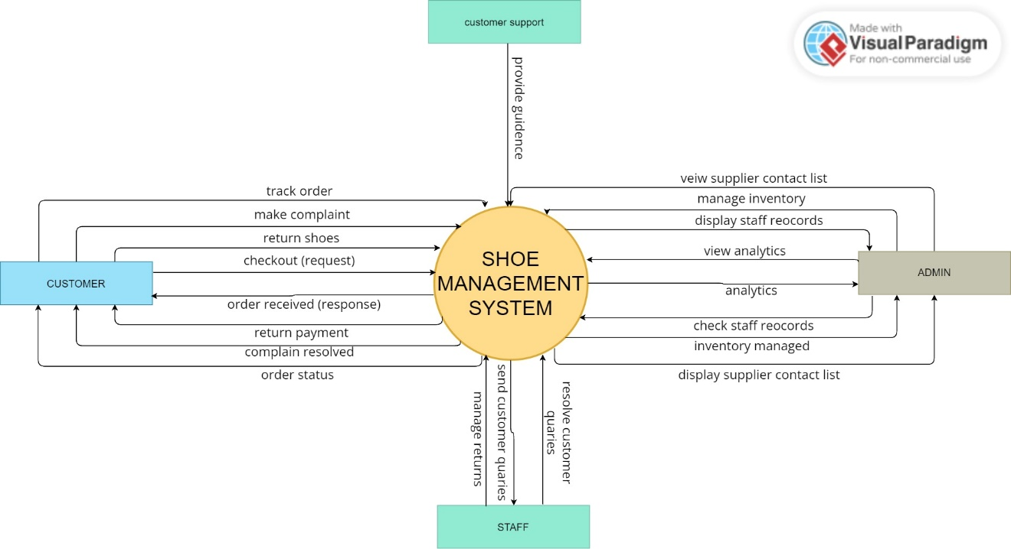

Figure : Context Diagram

This context diagram has four actor customer, Admin, Staff and customer support. Customers can register, browse the inventory, place orders, make payments, and track their orders. Admins have access to administrative functionalities such as managing customer complaints, analyzing sales and profits, and managing staff. Staff members are responsible for order fulfillment, inventory management, and customer support. The system maintains a record of customer details, purchase history, inventory information, complaints, orders, payments, shipping details, and analytics. Customers can raise complaints regarding their orders or purchased shoes. Orders are associated with specific customers and include details such as shoe size, color, price, and quantity. Payments are made by customers for their orders and can be of different payment methods. Shipping orders include information about the shipping address, method, cost, and date. The system also performs analytics to track total sales, profits, returns, complaints, and shoe inventory levels.

### Data Flow Diagram:

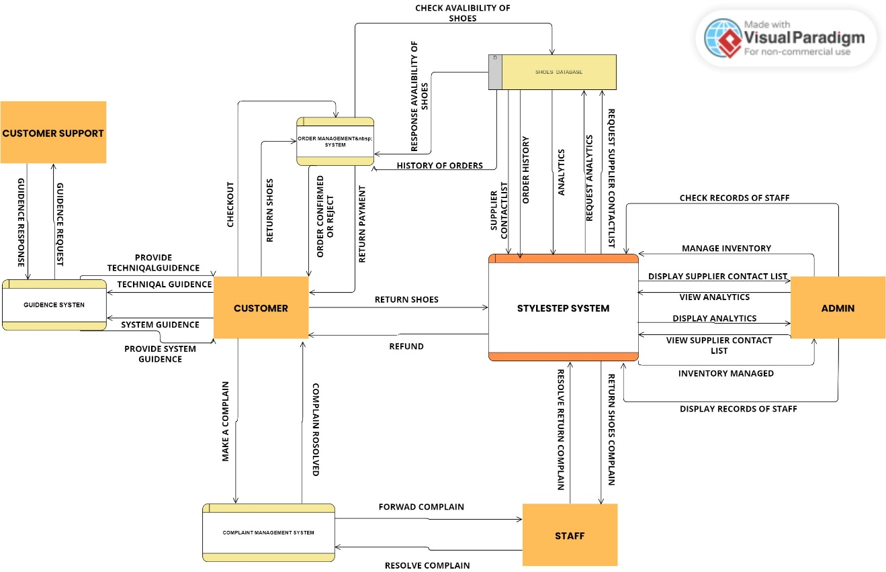

Figure : Data Flow Diagram

The Order Management process receives customer orders and verifies their availability in the inventory. If the ordered shoes are available, the process updates the inventory and generates an order confirmation. If the ordered shoes are not available, the process generates an out-of-stock notification. The Inventory Management process receives updates from suppliers regarding shoe details, including shoe name, brand, category, quantity, gender, season, and release date. The process updates the inventory data store with the received information. The Complaint Management process receives complaints from customers. It logs the complaint details, including the complaint description and date, in the complaint data store.Admin can access and manage the complaints through the Admin Functions process.

## User classes and characteristics

### User Classes:

* **Customers:** They have access to features such as browsing products, adding items to the cart, managing their accounts, making purchases, and tracking orders.
* **Store Managers/Administrators:** These users have administrative privileges and oversee the overall operation of the shoe management system.
* **Customer Service Representatives:** They may have access to features that enable them to assist customers with order tracking, account management, and resolving customer queries.
* **Inventory Managers:** They have access to features such as adding new shoe products, updating product details, managing stock levels, and handling inventory-related tasks.
* **Marketing and Sales Managers:** These users focus on promoting and driving sales for the shoe management system.
* **System Administrators:** These users are responsible for the technical administration and maintenance of the Shoe Management System.

## Operating environment

### Hardware Platform:

The Shoe Management System can run on a variety of hardware platforms, including servers, personal computers, laptops, tablets, and smartphones. The specific hardware requirements may vary depending on the scale and complexity of the system and the number of concurrent users it needs to support.

### Operating system(OS) Versions:

The system can be compatible with multiple operating system versions to accommodate different user devices. This may include popular desktop operating systems such as Windows, mac OS, and Linux, as well as mobile operating systems like Android and iOS. The compatibility ensures that users can access the system from their preferred devices and operating systems.

### Geographical Locations of Users:

The Shoe Management System can be accessed by users from various geographical locations around the world. The online platform is typically accessible globally, allowing users to browse products, make purchases, and manage their accounts from anywhere with internet connectivity.

### Servers and Databases and Their Hosts:

The Shoe Management System requires servers and databases to handle the processing and storage of data. The servers can be hosted either on-premises or in the cloud. On-premises hosting means that the servers are physically located within the organization's infrastructure. Cloud hosting involves utilizing infrastructure provided by cloud service providers, such as Amazon Web Services (AWS), Microsoft Azure, or Google Cloud Platform (GCP).

### Host Websites:

The Shoe Management System's online platform is typically hosted on dedicated websites or domains. These websites serve as the interface for users to access the system, browse products, make purchases, manage accounts, and track orders. The host websites can have their own domain names and are accessible through standard web browsers. The websites may implement secure protocols such as HTTPS to ensure secure communication between users and the system.

## Design And Implementation constraints

* **Security:**

The Shoe Management System needs to prioritize data security and protect sensitive user information, including personal details, payment data, and order history. Security constraints may include adherence to industry standards and best practices for data encryption, secure authentication mechanisms, and protection against common vulnerabilities such as cross-site scripting (XSS) or SQL injection attacks.

* **Scalability:**

The system should be designed to accommodate potential growth in user base, product catalog, and transaction volume. Scalability constraints may arise in terms of database performance, server capacity, and network bandwidth. The system should be capable of handling increased load and processing demands without significant degradation in performance.

* **User Experience:**

The system should provide a user-friendly and intuitive interface to enhance user experience. Constraints related to usability, accessibility, responsiveness, and cross-device compatibility should be considered during the design and implementation phases. The system should be designed to accommodate users with varying levels of technical expertise.

* **Integration with Third-Party Systems:**

The Shoe Management System may need to integrate with external systems, such as payment gateways, shipping providers, inventory management systems, or customer relationship management (CRM) platforms. Constraints related to API availability, compatibility, and data exchange protocols should be considered to ensure seamless integration with these systems.

* **Time and Budget:**

Design and implementation constraints can be influenced by project timelines and budgetary constraints. The system should be developed and implemented within the allocated time and budget while ensuring the delivery of essential features and functionalities. Prioritization and effective project management practices can help address time and budget constraints.

# System Features

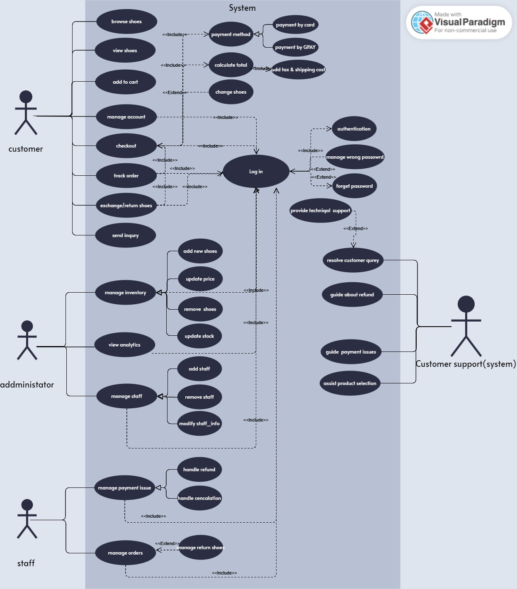

Figure : Use case Diagram

## System Feature 1

**System Feature:** Manage account

**Description**:

The ability for users to manage their account details, including updating personal information such as name, email, shipping address, and payment preferences.

**Functional Requirments:**

**FR-1:** User Authentication:

User shall be able to authenticate themselves using their username and password.

**FR-2:** Update Personal Information:

User shall have the ability to update their personal information, including name, email address, shipping address, and payment preferences.

**FR-3:** Password Reset:

User shall be able to request a password reset if they forget their password or want to change it.

**FR-4:** Account Deactivation:

Users shall have the option to deactivate their account if they no longer wish to use the system.

**FR-5:** Account Privacy and Security:

User shall ensure the privacy and security of user account information.

## System Feature 2

**System Feature:** Checkout

**Description:**

The checkout feature enables users to finalize their purchases and proceed with payment for the selected shoe products.

**Functional Requirements:**

**FR-1:** Display Selected Items

The system should display a summary of the selected shoe products in the user's shopping cart during the checkout process.

**FR-2:** Shipping Information

Users should be prompted to provide their shipping information, including address, contact details, and preferred shipping method.

**FR-3:** Payment Options

Users should be able to select their preferred payment method and provide the necessary payment details.

**FR-4:** Order Confirmation

User shall complete the checkout process, the system should display an order confirmation page.

## System Feature 3

**System Feature:** Manage Inventory

**Description:**

The manage inventory feature allows users to efficiently manage the inventory of shoes in the online platform.

**Functional Requirements:**

**FR-1:** Add New Shoe Products

User’s shall appropriate permissions should be able to add new shoe products to the inventory.

**FR-2:** Update Product Details

Users shall be able to update the details of existing shoe products in the inventory.

**FR-3:** Remove Discontinued or Out-of-Stock Items

Users shall have the ability to remove discontinued or out-of-stock shoe products from the inventory.

**FR-4:** Inventory Tracking:

The system shall keep track of the available quantity of each shoe product in the inventory.

## System Feature 4

**System Feature:** Manage Staff

**Description:**

The manage staff feature allows authorized users to effectively manage staff members within the shoe management system.

**Functional Requirements:**

**FR-1:** Create New Staff Accounts:

User with administrative privileges should be able to create new staff accounts within the system.

**FR-2:** Modify Staff Information:

Authorized user should have the ability to modify staff information as needed.

**FR-3:** Deactivate or Delete Staff Accounts:

User with appropriate privileges should be able to deactivate or delete staff accounts when necessary.

**FR-4:** Handle Staff Account Issues:

User should be able to reset passwords, unlock accounts, or address any staff account-related concerns promptly.

## System Feature 5

**System Feature:** Manage Payment Issues

**Description:**

The manage payment issues feature allows authorized users to handle and resolve payment-related problems within the shoe management system.

**Functional Requirements:**

**FR-1:** Identify Payment Errors:

User shall receive notifications or have access to a dashboard where they can view and identify payment errors.

**FR-2:** Resolve Payment Disputes:

User shall have the ability to handle payment disputes raised by customers, such as chargebacks or billing discrepancies.

**FR-3:** Refund Processing:

User shall appropriate privileges should be able to initiate and process refunds for valid payment errors or customer requests.

**FR-4:** Customer Support for Payment Inquiries:

User shall have access to customer information, transaction history, and relevant payment details to address payment-related concerns effectively.

# Data requirements

## Logical data model

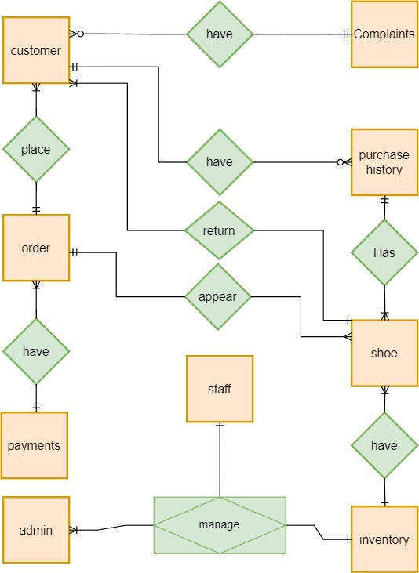

Figure : ERD Diagram

The ERD (Entity-Relationship Diagram) for the e-commerce system consists of several entities and their relationships. The main entity is the Customer, which represents the customers of the system. Each customer is identified by a unique Customer ID and can place multiple orders. The Order entity represents an individual order placed by a customer and is identified by a unique Order ID. Each order is associated with a specific customer and a shoe product. The Inventory entity represents the available shoe products in the system and is identified by a Shoe ID. The Purchase History entity tracks the purchase records of customers, including the Shoe ID, Shoe Size, Price, Quantity, and Purchase Date. The Payments entity records the payment details for each order, including the Payment ID, Order ID, Payment Method, Amount, and Date. The Shipping Orders entity tracks the shipping details for each order, including the Shipping ID, Order ID, Shipping Address, Shipping Method, Cost, and Date. The Complaint entity represents customer complaints and includes fields such as Complaint ID, Customer ID, Shoe ID, Complaint Date, Description, and Status. The Analytics entity provides summarized information such as total sales, profits, returns, and complaints, along with shoe inventory levels for different months. The Admin and Staff entities represent system administrators and staff members, respectively, with attributes such as Admin ID, Admin Name, Admin Email, Admin Phone Number, Admin Address, Admin Password, and Admin Role for administrators, and Staff ID, Staff Name, Staff Email, Staff Phone Number, Staff Address, Staff Password, and Staff Role for staff members. Lastly, the Supplier entity represents the shoe suppliers and includes attributes like Supplier ID, Supplier Name, Supplier Email, Supplier Phone Number, and Supplier Address.

# External interface requirements

## User interfaces

The user interface design for the e-commerce system, created using Figma, showcases a clean and modern layout with intuitive navigation and visually appealing elements. The design includes various screens and components that cater to different user interactions and tasks within the system. The interface follows a consistent color scheme and typography to ensure a cohesive and user-friendly experience. It incorporates elements such as product listings, search functionality, shopping cart management, user profile settings, order tracking, and payment processing. The design aims to provide users with a seamless and visually engaging interface that enhances their overall shopping experience.

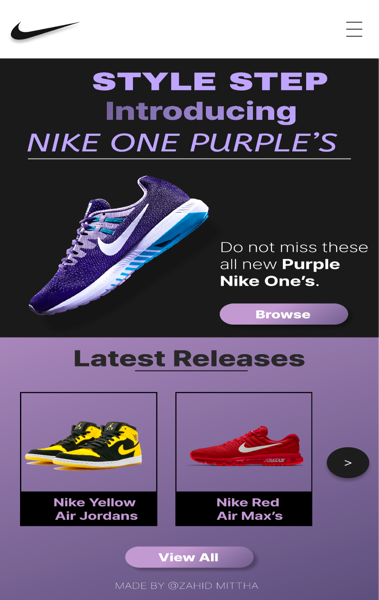

Figure : User Interface Home



Figure : User Interface View Shoes

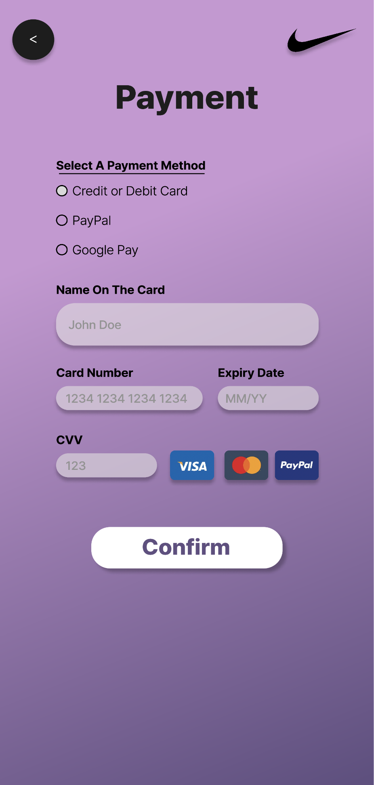

Figure : User Interface Payment

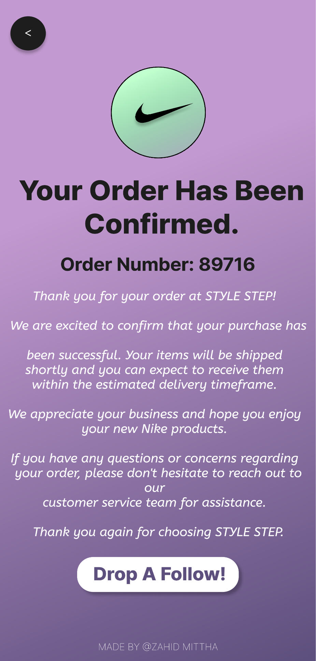

Figure : User Interface Order confirmation

# Quality attributes

**NFR-1:**

**Performance:**

The system should be able to handle a large number of shoe records and process requests efficiently. It should provide fast response times when searching, adding, updating, or deleting shoe information.

**NFR-2:**

**Usability:**

The user interface of the system should be intuitive, user-friendly, and easy to navigate. It should provide clear instructions and feedback to users, helping them perform tasks effectively.

**NFR-3:**

**Security:**

The system should implement strong security measures to protect the confidentiality, integrity, and availability of shoe data. It should include authentication mechanisms to control access to the system and have proper authorization levels for different user roles.

**NFR-4**

**Safety:**

The system should implement strong safety measures to protect the confidentiality, integrity, and availability of shoe data. It should include authentication mechanisms to control access to the system and have proper authorization levels for different user roles.

**NFR-5:**

**Maintainability:**

The system should be designed in a modular and maintainable way, allowing for easy updates, enhancements, and bug fixes. It should have well-documented code and follow coding best practices to facilitate maintenance by developers.

**NFR-6:**

**Compatibility:**

The system should be compatible with different platforms and devices, allowing users to access it from various devices such as desktop computers, tablets, and smartphones. It should also integrate smoothly with other systems or APIs that may be necessary for shoe inventory management.

**NFR-7:**

**Scalability:**

The system should be scalable to handle an increasing number of shoe records and user traffic. It should be able to accommodate future growth and expansion without significant performance degradation.

**\*\*\*\*\*\*\*\*\*\*\*\*\*\*\*\*\*\*\*\*\*\*\*\*\*\*\*\*\*\*\*\*\*\*\*\*\*\*\*\*\*\*\*\*\*\*\*\*\*\*\*\*\*\*\*\*\*\*\*\*\*\*\*\*\*\*\*\*\***

**\*\*\*\*\*\*\*\*\*\*\*\*\*\*\*\*\*\*\*\*\*\*\*\*\*\*\*\*\*\*\*\*\*\*\*\*\*\*\*\*\*\*\*\*\*\*\*\*\*\*\*\***

**\*\*\*\*\*\*\*\*\*\*\*\*\*\*\*\*\*\*\*\*\*\*\*\*\*\*\*\*\*\*\*\*\***

**\*\*\*\*\*\*\*\*\*\*\*\*\*\*\*\***